Deus Mons – the Castle of Miraak

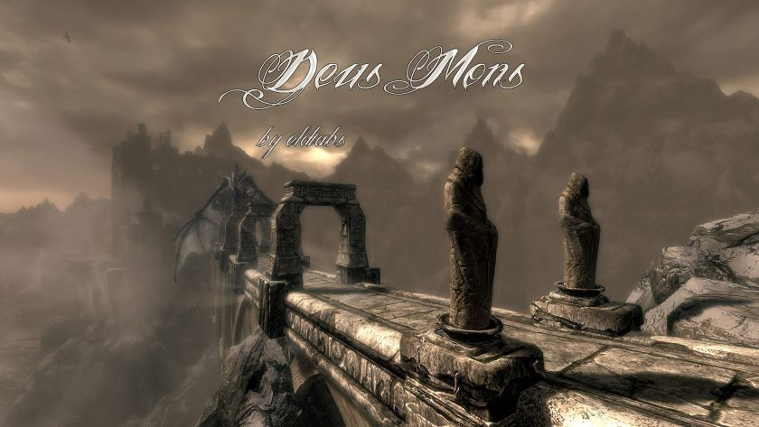

Version: 2.2.1
Author: original mod by eldiabs (from Oldrim), overhauled by Amras Anárion
Contributors: ElDiabs (story, design), Amras Anárion (story overhaul, major enlargement), koaandl (NPCs), Utopolyst (NPC edits), Ghosu (3D model of the sword Zahkrii do Dovahkiin)
Date: 08/10/2017
Category: Houses
Language: English
Prerequisites: Skyrim Special Edition or Oldrim with the 3 DLCs

A wonderful stronghold among the oldest of Skyrim. The legend says that Miraak himself would have built it. A legacy that deserves to be perpetuated on Special Edition … because nothing is worthier for a Dragonborn than a house built by a Dragonborn.

Situated just south of the Throat of the World, atop a small peak, lies Deus Mons, or the God Mountain, known as Strunmah Rahus among the Dov.

The origin of Deus Mons dates back several millennia, when Skyrim was a young land and the Dragons flew high in the sky. The legend says that a Dragon Rider would have built it to make it his home. A castle difficult to access by road, but easily by the air... Until the day when this 'Son of Dragon' disappears somewhere in the island of Solstheim, leaving eternal snows of the Throat of the World to cover it...

The centuries that followed were little documented. It is said that Jarls or Lords - amazed at the beauty of the building - felt the desire to restore it to make it their second home... but the altitude and the difficulty of access through the path of the Seven Thousand Steps were stronger than their dedication...
The castle fell in serious disrepair until a few years ago, when an anonymous and extremely wealthy nobleman from Cyrodiil commissioned craftsmen from Markarth to rebuild the bridge and renovate some of the interior. Rumor has it said nobleman intended on making Deus Mons his summer retreat, as like its predecessors of the Skyrim elite... Unfortunately, a Dragon - Keeper of the place according to legend - have appeared from nowhere; and rumor has it the nobleman was mysteriously assassinated by unknown parties, if not by the Dragon himself.
Even more interesting is the whispers from the locals in Ivarstead. They say the last craftsmen to flee the castle were attacked by its guardian an eaten whole, leaving no survivors. Apparently, this Dragon is of immense size, and if one still plans on viewing this glorious structure, it is best to keep a considerable distance from the bridge. The Dragon seems to have taken up residence there.

Author's note: I recommend you first head to Vilemyr Inn in Ivarstead and look for a book in one of the rooms. No quest attached, so it isn’t necessary, but it provides a bit of a backstory.

Take down a powerful Dragon to obtain the key to Deus Mons!

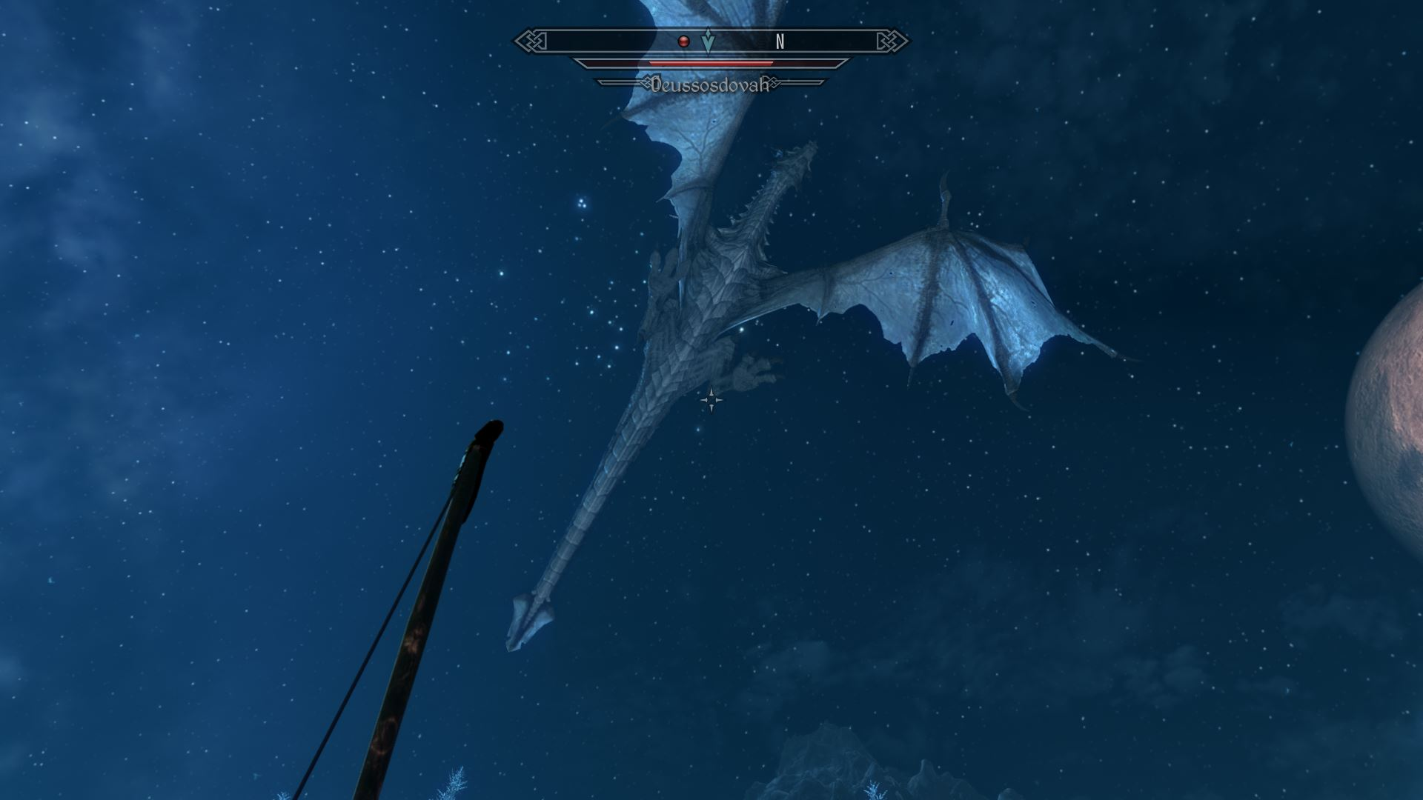

Sent by Miraak from Apocrypha to keep the castle, Dessosdovah is level 60 and has 3000 HP, about the same as Alduin. It's a tough fight, Deus Mons must be earned.
A wise advice: the terrain is rugged and the Dragon tends to easily go away. Furthermore, he has few places to land. Abuse of saves in case you lose sight of it.
Also, if you are wondering why this Dragon has no soul ... Miraak has already taken it. ;)

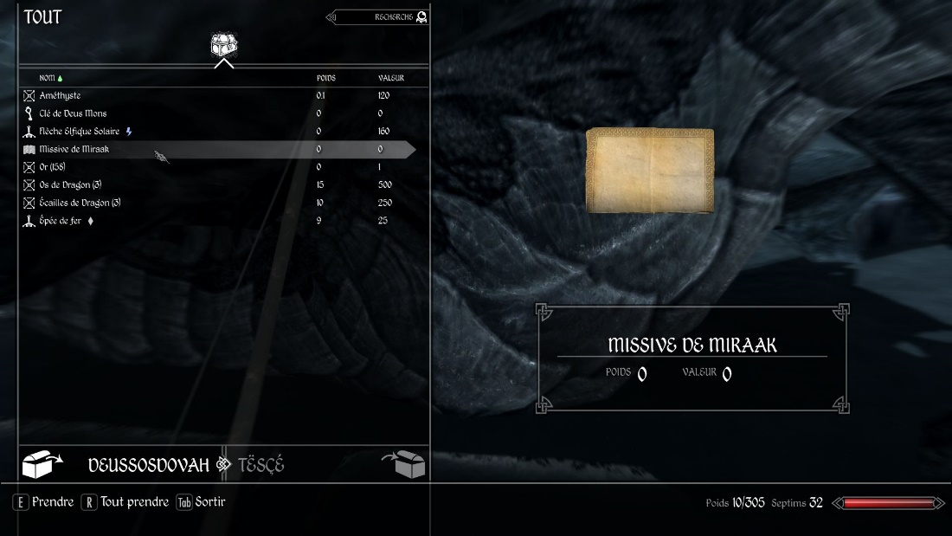

Hall of Heroes and Gods

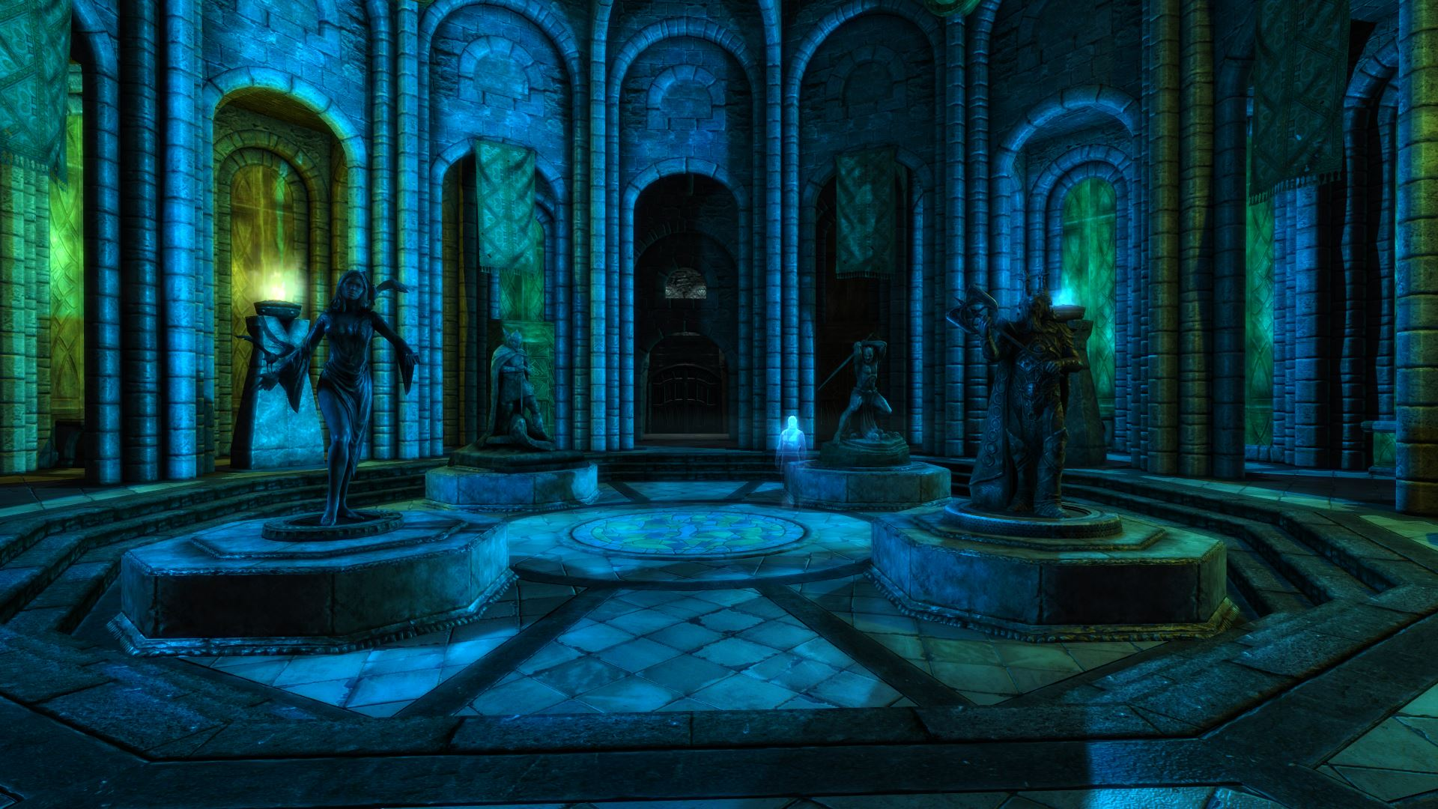

There are the altars of the Nine Divines. Ideal with my mod "Cumulative Blessings".

Enjoy the Underfalls

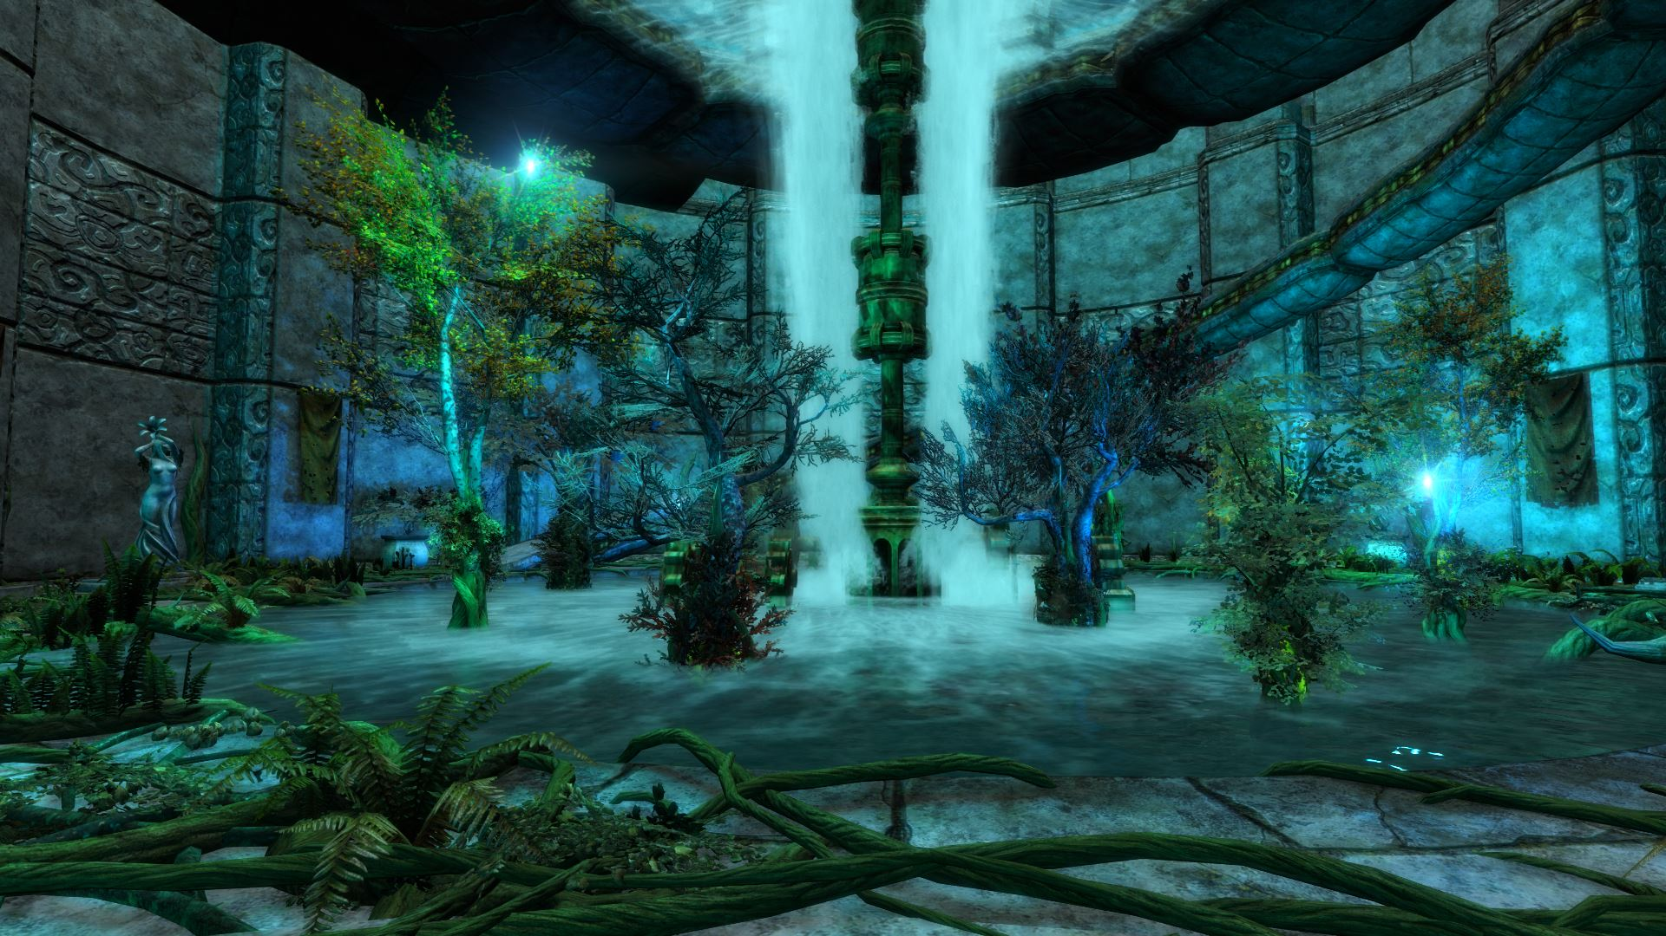

Garden in the Overfalls

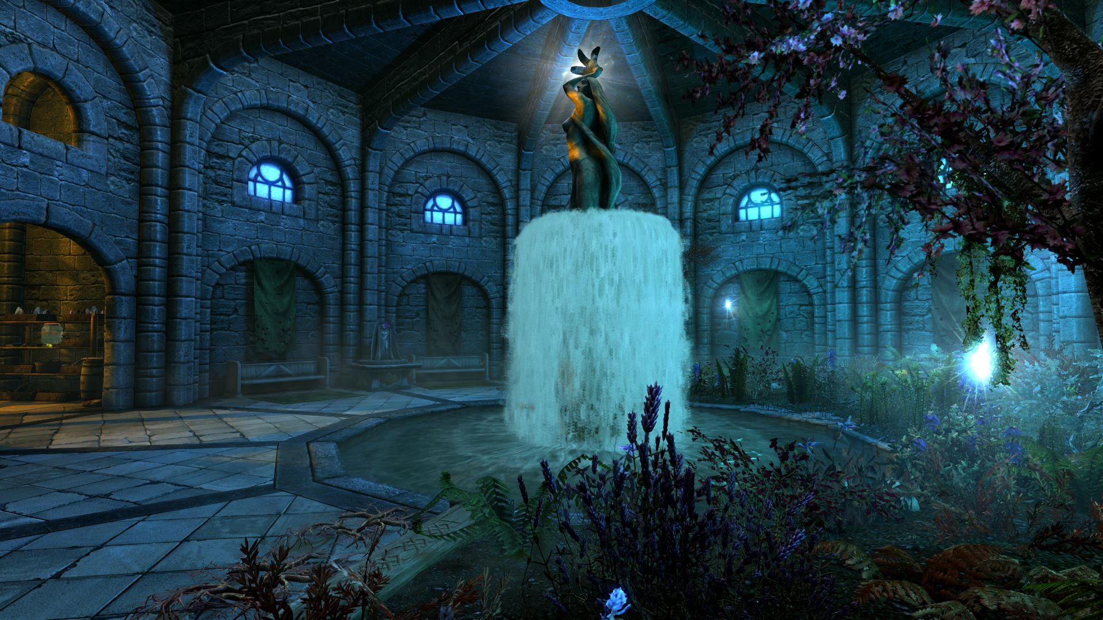

A paradise for Alchemists and Mages ...

Pool area...ish

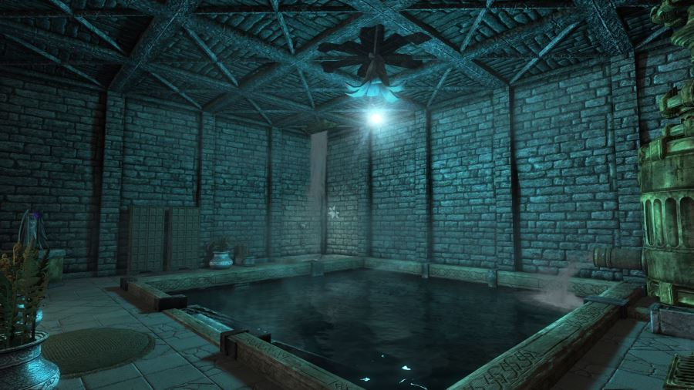

Living Quarters

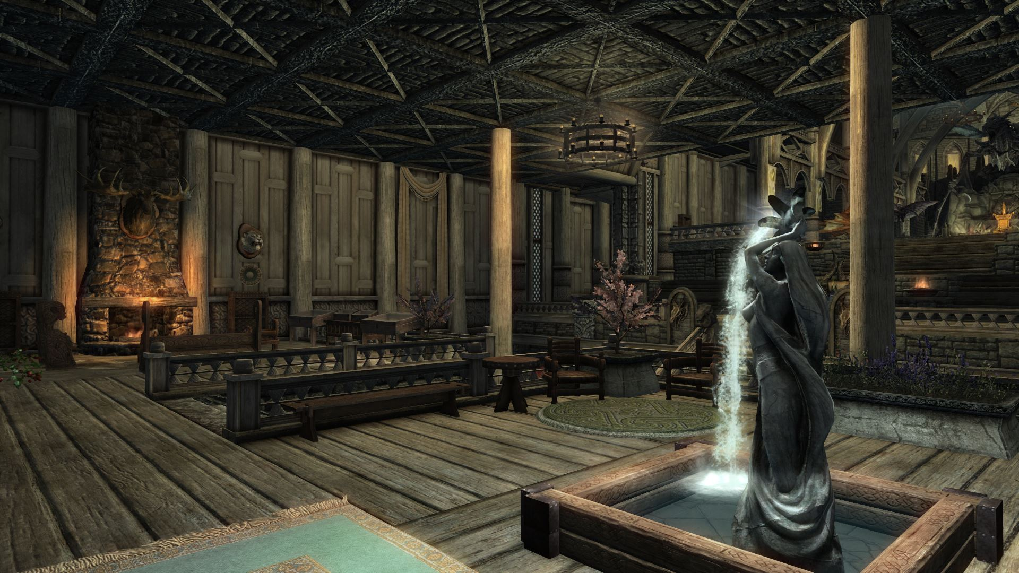

A very large cell with several rooms:
- A library (image above)
- A dwemer sauna (image still above)
- A dwemer forge with all crafting stations
- A kitchen
- A room for the servants
- A guest room for your followers.
- The Bedroom of the Lord Dovahkiin
- The Bedroom of Children's Dovahkiin. Invite your family here with the "Hearthfire Multiple Adoptions" mod.
- A secret passage to the foot of the mountain, leading to a brand-new dungeon.
- A vault room
- An armory with the support for the Masks of the Priests-Dragons and several racks.
- Showers, toilets, basins and sinks with activators to run the water!
- Numerous mannequins and showcases to proudly display your hunting trophies!
- A teleport spell to allow you to return to Deus Mons.
- A large throne room directly accessible by taking the new staircase.

The Throne Room

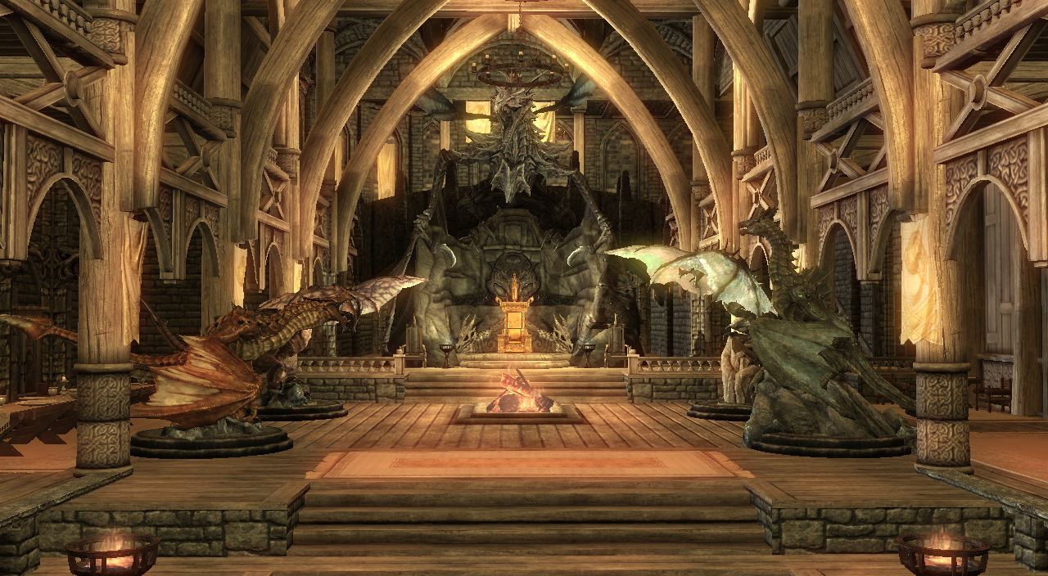

The Throne Room is one of the major new features of Deus Mons 2.0. Proudly display your Dragonborn blood through the Miraak's legacy. Moreover, the first Son of Dragon has left behind him some relics that will help you in your mastery of the Thu'um and your confrontations against the Dov.
- 2 new swords, 2 draconic jewels and a scepter to dominate all Dragons!
- A unique throne, on which sat previous Dragonborns.
- A Dragon Museum: admire their magnificent replicas! (Possibility to climb them and jump on them!)
- Many steles to learn more about them as well as about the former owners of the castle. You discover that the draconic name of Deus Mons is Strunmah Rahus. It originates from the mountain on which the castle is built.

A large door to the rear will allow you to take in fresh air and enjoy a splendid view.

Auriel’s Balcony

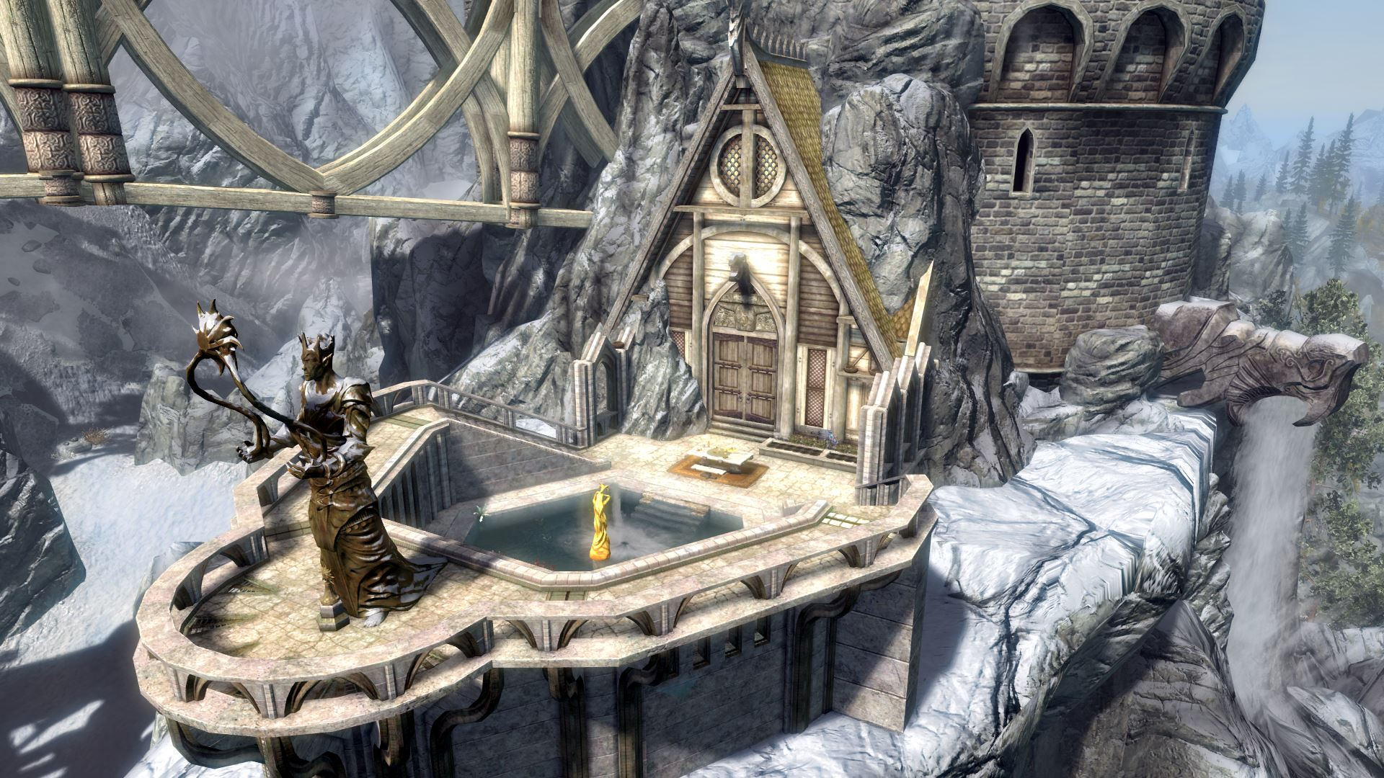

Accessible from the Throne Room, you can walk on the last work of the nobleman of Cyrodiil, who appears to be a descendant of Ocato of Firsthold. This explains why he wanted to pay tribute to Auriel by adding his loan to Strunmah Rahus.

This belvedere will be appreciated by your children and you will offer a small corner of gardening. The altar dedicated to the elvish Akatosh is of course present.
Two teleporters on each side will allow you to travel instantly to Whiterun or Winterhold.

NPCs

Deus Mons includes seven NPCs to make the castle less lonely:
- A Bard
- A Hunter (trader)
- A Blacksmith (trader)
- A Cook (trader)
- A Thief/Gardener
- A Librarian (trader)
- A Priestess

All NPCs have their own schedules, and will wander about the Castle doing their chores and business, interacting with the environment. Talk to the ghost in the Hall to recruit them.

Companion NPCs:

- An "Aural Paladin", a Strong, Two-Hander wielding warrior, with the ability to heal himself and others, as well as repelling undead monstrosities. Has a fast, flanking combat style, preferring to swing from the front or sides in fast strikes with occasional power attacks, and little blocking.

- A "Rogue", a Quick, Agile Khajit, who dual wields daggers, with the ability to poison and slow foes. Enters combat by poisoning or slowing nearby foes, and using his bow until an enemy closes in. When confronted by a melee range enemy, he will circle them and stab quickly.

Guards

- Guards may be purchased for the Castle, they will maintain a post, occasionally wandering. There are one to two guards for every area, except for the Underfalls.

The expansion project of Deus Mons was realized and my promise kept. To achieve this, I faced two challenges:
• Clean the mod thoroughly. Indeed, the old plugin still contained critical bugs and dirty entries.
• Increase my modding skills, especially in level design and scripts, in order to realize my ideas and aspirations.

That said, the adventure does not end there. Currently, I have hoisted Strunmah Rahus to the level of the other mods of castles, but I intend to go further.
Let's not forget that this mod has not really been updated since 2013 after Eldiabs was blocked by a dead end because of a corrupt plugin. When I think that from 2014, he officially asked players not to download his mod anymore, that's where I realize all the way accomplished.

Proud of this advance, I have as a project for Deus Mons, including a future version 3.0 which will include two official quests to take possession of Deus Mons, a third to discover the secrets of its depths, and a fourth consisting of solving the enigma of Miraak.
• The first quest is the one you already know, but is "invisible." It is about finding the book at Ivarstead, going to Strunmah Rahus, killing his Dragon, taking his key, talking to the ghost and recruiting your royal court. An advantage of this quest will be that Deusosdovah will receive a quest marker on his head. No more the risk that it disappears behind the horizon without you find it!
• The second quest involves the expansion of Deus Mons. Currently, the Throne Room is freely accessible. In a future update, it will be encumbered by a landslide, and it will be necessary to find the foreman of Markarth to complete the noble task of Thijik Alinwë.
• The third quest will be the Catacombs of Deus Mons. This cell is destined to become a complete dungeon, with monsters, loots and a Boss to kill: the relics of Miraak which will have to be deserved.
• The fourth quest will be an enigma to be solved in Deus Mons in order to gain access to the Hermaeus Mora Library. Read the scattered clues, find the right combination and take the knowledge of the Daedra of Knowledge.

In the intermediate versions (2.3, 2.4 ...), I plan to improve the trophy room. Thanks to the new scripts, it will be possible to proudly expose most of the unique objects of the game. I also think to add some unique spells, which you can buy from the Priestess (currently without interaction).

If is your first installation of Deus Mons or from a 2.1 or newer version

1. Extract the ESP and the BSA from the archive.
2. Install them in your Steam\SteamApps\common\Skyrim Special Edition\Data folder and allow file replacement if prompted.
3. Launch the Nexus Mod Manager and activate the plugin of Deus Mons.

If you installed an old version of Deus Mons (2.0 and older)

!!! IMPORTANT !!!

Version 2.x (and later) is a major and critical update. The original ESM no longer exists, which implies that the game will recognize this mod as being different from the old one. To avoid conflicts with the BSA archive, you will have to manually delete all the old loose files, namely:

File: Data\Deus Mons.esm
File: Data\Deus Mons.esp (first versions 0.x) or Data\Deus Mons_WithNPCs.esp (1.x versions)
Directory: Data\Textures\ElDiabs
Directory: Data\Meshes\Actors\Character\FaceGenData\FaceGeom\Deus Mons_WithNPCs.esp
Directory: Data\textures\Actors\Character\FaceGenData\FaceTint\Deus Mons_WithNPCs.esp

As well as the following scripts if they are present (very important !!):

Data\scripts\DeusInterrupteur.pex (0 kb)
Data\scripts\DeusMons_Bard.pex (0 kb)
Data\scripts\DeusMons_Blacksmith.pex (0 kb)
Data\scripts\DeusMons_Chef.pex (0 kb)
Data\scripts\DeusMons_Guards.pex (1 kb)
Data\scripts\DeusMons_Hunter.pex (0 kb)
Data\scripts\DeusMons_Librarien.pex (0 kb)
Data\scripts\DeusMons_Priestess.pex (0 kb)
Data\scripts\DeusMons_Thief.pex (0 kb)
Data\scripts\DeusStele.pex (0 kb) (2.0 beta)
Data\scripts\DeusSteleDouble.pex (1 kb) (2.0 beta)
Data\scripts\DeusSteleTriple.pex (1 kb) (2.0 beta)
Data\scripts\DeusTeleportHorseEye.pex (1 kb) (2.0 beta)
Data\scripts\TIF__020089E1.pex (0 kb) (2.0 beta)
Data\scripts\TrapLever.pex (0 kb) (2.0 beta)
Data\scripts\FixZDrift.pex (0 kb) (1.2.3 and older)
Data\scripts\LightingBall.pex (8 kb) (1.2.3 and older)
Data\scripts\LightingBallController.pex (8 kb) (1.2.3 and older)
Data\scripts\TIF__020089E1.pex (0 kb) (1.2.3 and older)

If you restart from a save that has already experienced a 0.x or 1.x version of Deus Mons

For the reason mentioned above, it is advisable to start on a fresh save with the new version of this mod. If nevertheless you want to keep your hero and make him benefit from the last version of Deus Mons, it will be necessary to follow the following procedure:
• Retrieving all your stored treasures and saving them in a secure location (a vanilla home for example)
• Save your hero on an isolated cell (a vanilla home also)
• Disable the plugins and delete the old files (list below)
• Restart Skyrim and make a save again.
• (Recommended if you have the skills) Clean the orphaned scripts of your save with ReSaver or similar tool.
• Install, activate and launch the 2.x or newer.
• Play!

Note that thanks to a complete cleaning of the plugin (merge of the ESP + of the ESM, correction of all the errors and creation of a BSA), the future updates of Deus Mons can be done with serenity by simply replacing the ESP file and its BSA archive.

Uninstall

Please save enough away from a cell modified by this Mod.

1. Launch the Nexus Mod Manager and disable the Deus Mons plugin.
2. Remove the ESP and the BSA associated with this mod.

Update (from version 2.1 or higher)

Simply replace the ESP file and the BSA archive with the new ones.

I admit: despite an automatic cleaning by SSEEdit and the CK 64 bits, the old plugin v1.2.3 still contained many errors and bugs.
I resumed the cleaning manually with meticulousness and then I managed to merge the ESM with its "patching" thanks to Merge Plugins.
Today, I am happy to propose a clean and fully restored mod with no errors or bugs.
If nevertheless you encounter worries, do not hesitate to let me know.

Versions lower than 1.2.2
Check the description of the original mod: http://www.nexusmods.com/skyrim/mods/11803/

1.2.2
• Enhancement of Deus Mons’ history and corrects some events with respect to the Lore.
• Rename “Deussosdova” to “Deussosdovah” (“God – Blood – Dragon” in Dra
conic language)
• Adds a note of Miraak in the body of Deussosdovah (Just for RP immersion)

1.2.3: ESM and ESP cleaning by CK 64 bits + SSEEdit 3.1.3, ITMs removed, UDRs fixed.

2.0 / 2.1 / 2.1.5 / 2.2:
• Huge cleaning, merge of the ESM/ESP, creation of a BSA archive, fix of almost all bugs and all the new features listed in "new features of 2.1 version".
• Fully compatible with Hearthfire Multiple Adoptions!!! All amenities for a happy home are available.
• Add large Throne Room
• Dragon museum: adding several steles which retrace the history of the castle.
• Add Auriel's Balcony
• Laying the foundations of Catacombs of Deus Mons. This dungeon is empty at the moment and contains only one chest, but it has as a secret passage...
• 5 relics of Miraak are available! Two jewels, two swords (the same one and two hands) and a scepter. It will be necessary to find a key near the dragons for the jewels and the swords. For the scepter, it is in free access, but it will have to be merited during a future update.
• Add a diary retracing the reconstruction of Deus Mons.
• The bard knows how to sing!
• A teleport spell is available to return to Deus Mons.
• Two teleport gates allow instant travel to Whiterun and Winterhold.
• Enlargement of the servants' room.
• Add Guest Room.
• Add showers, ponds, toilets and taps with activator.
• New scripts for display trophies. More options and no risk of conflict.
• Translation into English fully completed.

2.2.1 (Oldrim): Fixed the Gray Face bug on the NPC of Deus Mons (FaceGen Data regenerated from the CK of Oldrim, because those of SSE are not recognized) + typo of Sima fixed.

Mod under a Creative Commons license - Attribution 4.0 International - CC BY NC 4.0
• You have the right to modify and / or upload it to another site from the moment you credit me and Eldiabs.
• No commercial use of this Mod.

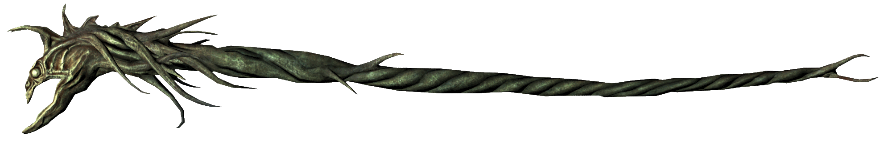

My other Mods:

Auriel's Weaponry
A lore friendly overhaul for Auriel's Bow and his other relics

Masterspells
Unlocks and balance the power of level-master Spells and enhances Dual Cast.

Cumulative Blessings
Allow stacking several God’s blessings and slightly reinforces half of them.

