Activateur 1 : (Volsung)
Trigger (boîte rouge) : dunLabyrinthianBustTriggerCorundrum (F8486)
+ Linked ref : DragonPriestMaskCorundum01 (81D6C) dans LabyranthianPriestSanctuary
+ Script dunLabyrinthianMaskBustSCRIPT
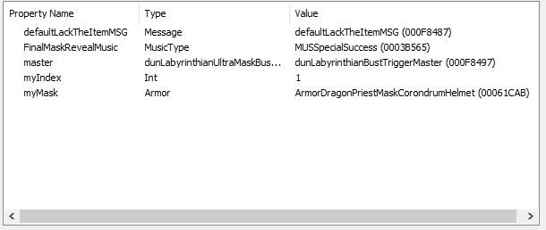

Support 1 :
DragonPriestMaskCorondrum01 (81D6C)
Linked From dunLabyrinthianBustTriggerCorundrum (F8486)

------------------------------------------------------

Activateur 2 : (Vokun)
Trigger (boîte rouge) : dunLabyrinthianBustTriggerSteel F8488
+ Linked ref : DragonPriestMaskSteel01 (81D6B) dans LabyranthianPriestSanctuary
+ Script dunLabyrinthianMaskBustSCRIPT
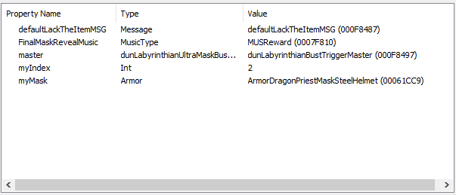

Support 2 :
DragonPriestMaskSteel01 (81D7A)
Linked From dunLabyrinthianBustTriggerSteel (F8488)

------------------------------------------------------

Activateur 3 : (Otar)
Trigger (boîte rouge) : dunLabyrinthianBustTriggerMarble (F848A)
+ Linked ref : DragonPriestMaskMarble01 (81D68) dans LabyranthianPriestSanctuary
+ Script (réglages hérités) dunLabyrinthianMaskBustSCRIPT
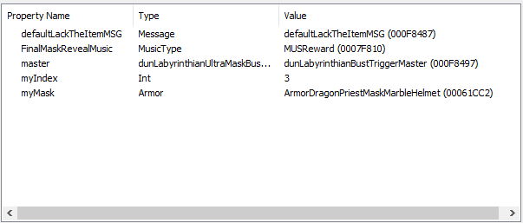

Support 3 :
DragonPriestMaskMarble01 (81D76)
Linked From dunLabyrinthianBustTriggerMarble (F848A)

--------------------------------------------------------------------------------

Activateur 4 : (Morokei)
Trigger (boîte rouge) dunLabyrinthianBustTriggerMoonstone (F848C)
+ Linked ref : DragonPriestMaskMoonstone01 (81D67) dans LabyranthianPriestSanctuary
+ Script (réglages hérités) dunLabyrinthianMaskBustSCRIPT
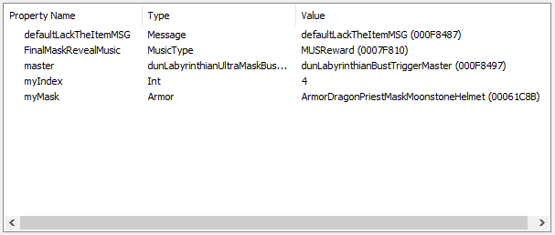

Support 4 :
DragonPriestMaskMoonstone01 (81D67)
Linked From dunLabyrinthianBustTriggerMoonstone (F848C)

--------------------------------------------------------------------------------

Activateur 5 : (Konahrik) (Maître)
Trigger (boîte rouge) dunLabyrinthianBustTriggerMaster (F8497)
+ Linked ref : DragonPriestMaskAltarMovableStatic (81D64) dans LabyranthianPriestSanc.
+ Script (réglages hérités) dunLabyrinthianUltraMaskBustSCRIPT

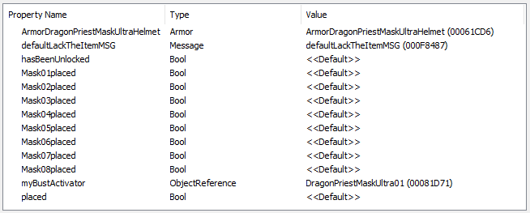

Support 5 :
DragonPriestMaskUltra01 (81D71)
Linked From DragonPriestMaskAltarMovableStatic (81D64)

--------------------------------------------------------------------------------

Activateur 6 : (Rahgot)
Trigger (boîte rouge) dunLabyrinthianBustTriggerOrichalum (F848E)
+ Linked ref : DragonPriestMaskOrichalum01 (81D70) dans LabyranthianPriestSanctuary
+ Script (réglages hérités) dunLabyrinthianMaskBustSCRIPT
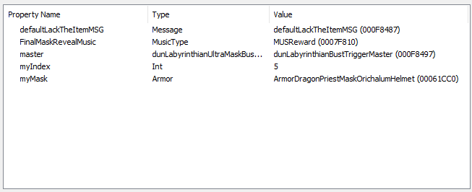

Support 6 :
DragonPriestMaskOrichalum01 (81D70)
Linked From dunLabyrinthianBustTriggerOrichalum (F848C)

--------------------------------------------------------------------------------

Activateur 7 : (Nahkriin)
Trigger (boîte rouge) dunLabyrinthianBustTriggerEbony (F8490)
+ Linked ref : DragonPriestMaskEbony01 (81D6F) dans LabyranthianPriestSanctuary
+ Script (réglages hérités) dunLabyrinthianMaskBustSCRIPT
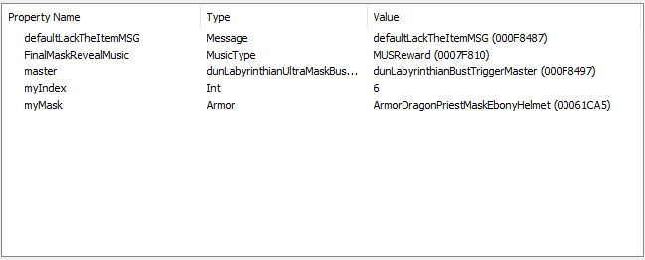

Support 7 :
DragonPriestMaskEbony01 (81D74)
Linked From dunLabyrinthianBustTriggerEbony (F848C)

--------------------------------------------------------------------------------

Activateur 8 : (Hevnoraak)
Trigger (boîte rouge) dunLabyrinthianBustTriggerIron (F8492)
+ Linked ref : DragonPriestMaskrIron01 (81D6E) dans LabyranthianPriestSanctuary
+ Script (réglages hérités) dunLabyrinthianMaskBustSCRIPT
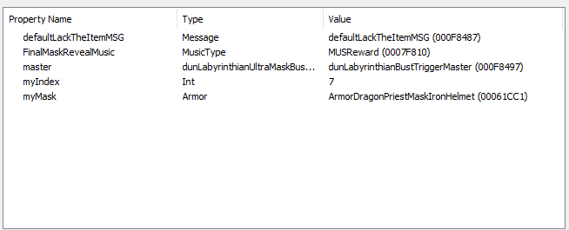

Support 8 :
DragonPriestMaskIron01 (81D77)
Linked From dunLabyrinthianBustTriggerIron (F848C)

--------------------------------------------------------------------------------

Activateur 9 : (Krosis)
Trigger (boîte rouge) dunLabyrinthianBustTriggerBronze (F8494)
+ Linked ref : DragonPriestMaskBronze01 (81D6D) dans LabyranthianPriestSanctuary
+ Script (réglages hérités) dunLabyrinthianMaskBustSCRIPT
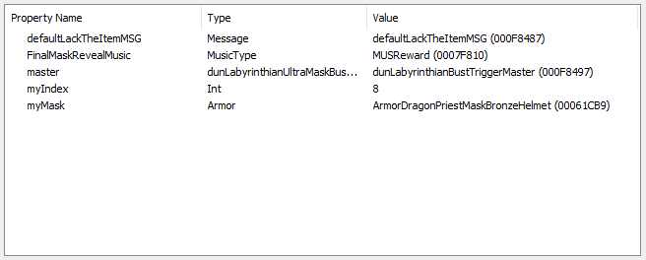

Support 9 :
DragonPriestMaskBronze01 (81D6D)
Linked From dunLabyrinthianBustTriggerBronze (F848C)

--------------------------------------------------------------------------------

Volsung
Armor\DragonPriestHelms\Dragonhelm_Corondrum_GO.nif

Vokun
Armor\DragonPriestHelms\Dragonhelm_Steel_GO.nif

Otar
Armor\DragonPriestHelms\Dragonhelm_Marble_GO.nif

Morokei
Armor\DragonPriestHelms\Dragonhelm_Moonstone_GO.nif

Konahrik (master)
Armor\DragonPriestHelms\Dragonhelm_Ultra_GO.nif

Rahgot
Armor\DragonPriestHelms\Dragonhelm_Greenstone_GO.nif

Nahkriin
Armor\DragonPriestHelms\Dragonhelm_Ebony_GO.nif

Hevnoraak
Armor\DragonPriestHelms\Dragonhelm_Iron_GO.nif

Krosis
Armor\DragonPriestHelms\Dragonhelm_Bronze_GO.nif

Wooden Mask
Armor\DragonPriestHelms\Dragonhelm_Wood_GO.nif

---

Ahzidal (fire)
DLC02\Armor\AcolyteMasks\AcolyteMask_GND.nif

Dukaan (frost)
DLC02\Armor\AcolyteMasks\AcolyteMask_GND.nif

Zahkriisos (shock)
DLC02\Armor\AcolyteMasks\AcolyteMask_GND.nif

Cultist Mask
DLC02\Clothes\Cultist\M\GO_Helmet.nif

Miraak
DLC02\Clothes\MiraakRobes\MiraakHelm_GND.nif

